MovieStats

|  |  |
| --- | --- |
| Title: | MovieStats |
| Date: | 12-10-2020 |
| Overview: | A real-time interactive website made using **Python Flask, Natural Language Processing, HTML, CSS, and JavaScript,** which provides real-time sentiment analysis of IMDB reviews and tweets of any movie user enters. The real-time data which is being scraped from the **Twitter** and **IMDB API** is visualized using **Chart.js**. Built a Sentiment. Analysis model using the **Naive Bayes** algorithm which provides an accuracy of 98.7%. |
| Datasets | * data.csv * database.csv * final_data.csv * main_data.csv * movie_metadata.csv * Review_status.csv * Sentimentcheck.csv |
| ML Model | * sentiment.ipynb * nlp_model.pkl * trasform.pkl |
| .ipynb_checkpoints | * sentiment-checkpoint.ipynb |
| Templates(HTML5) | * home.html * dashboard.html * tweets.html * moviereviews.html * contactus.html * thankyou.html * 404.html |
| Static(CSS+JS) | **CSS**  **JS**  **Images:**   * Background-check.jpeg * Contact.png * Favicon.png * Movie-stat.png |
| Python | app.py |

**Project Structure**

Virtual Environment

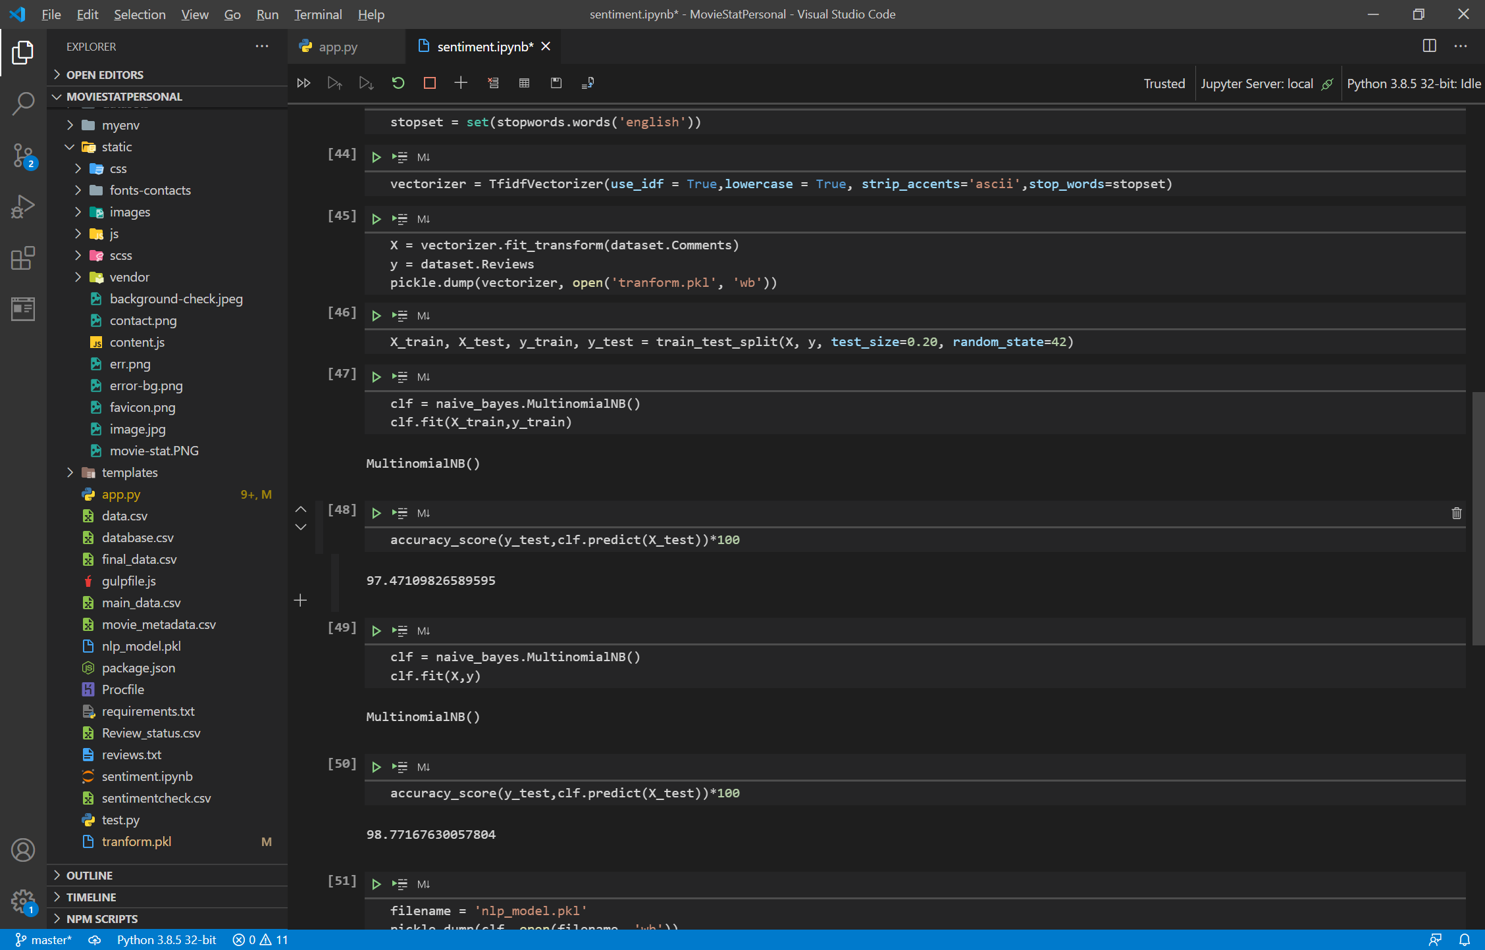

Sentiment Analysis Notebook

Heroku hosting Procfile

App.py(main Python file

Vectorizer mode

Sentiment model file

Templates(HTML)

Images

JS Files

CSS Files

Static Files

**Templates:**

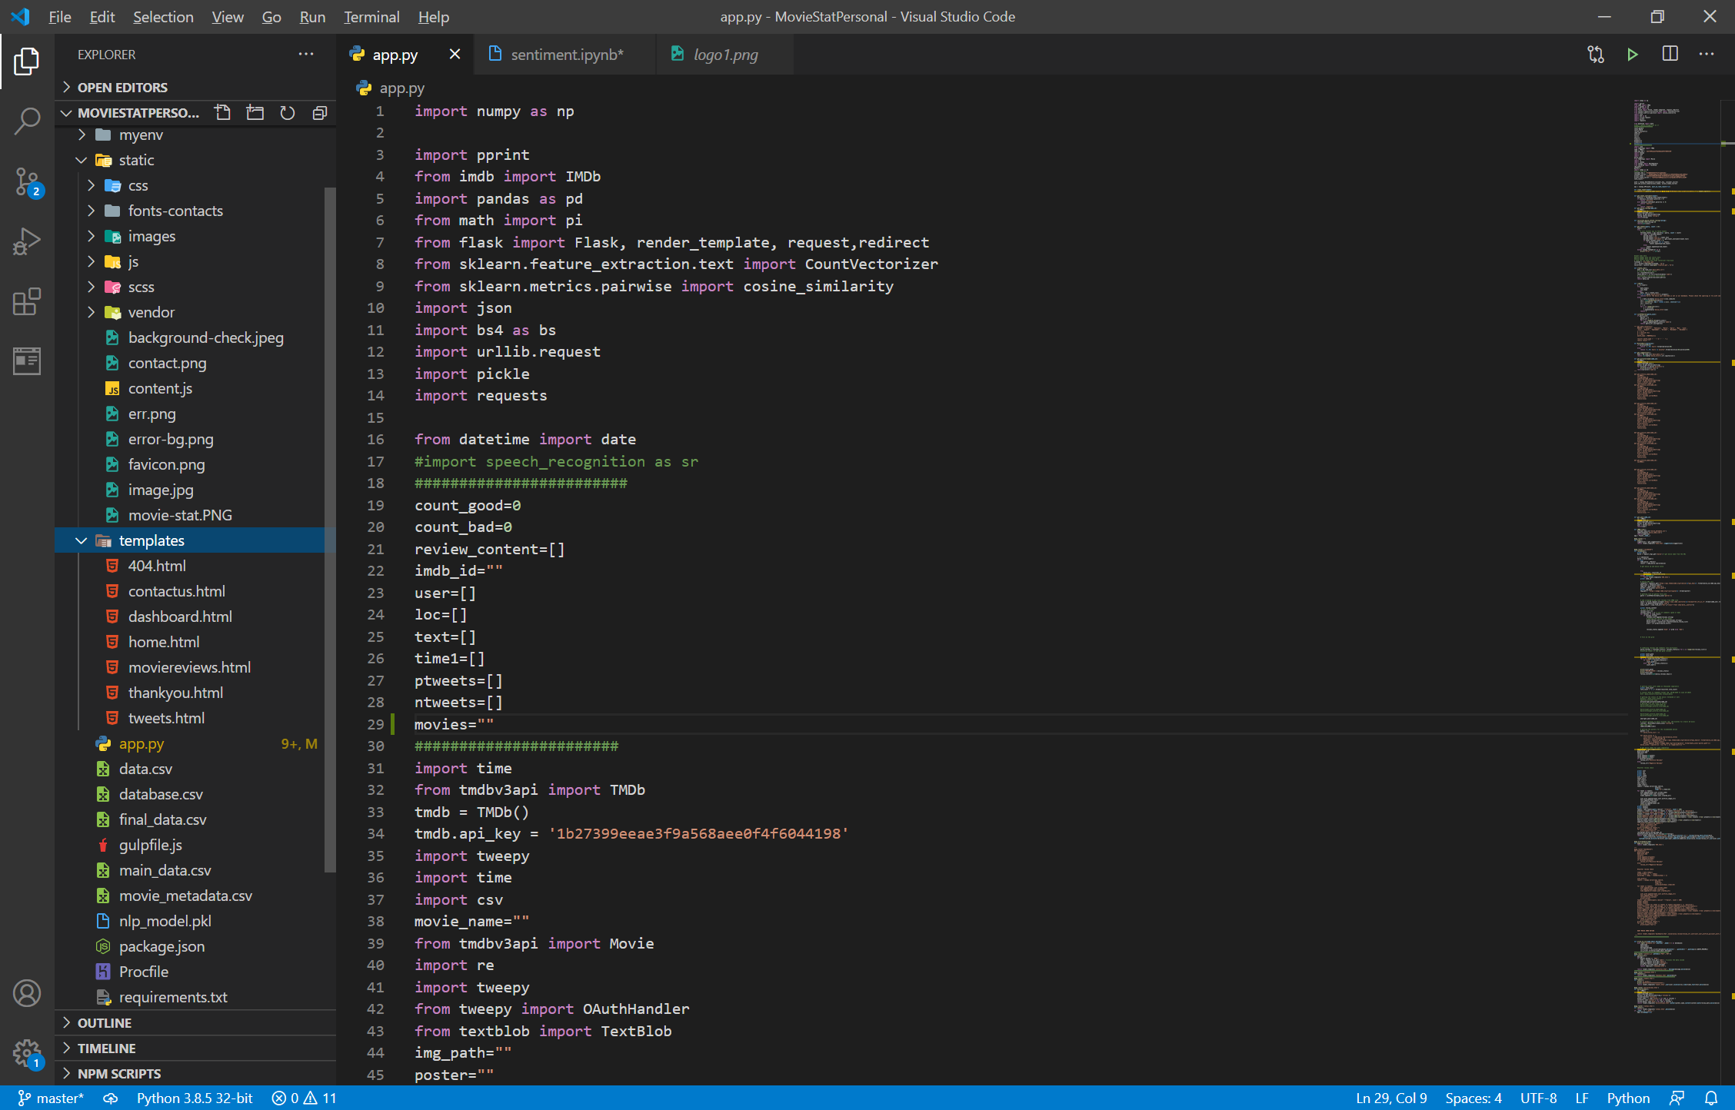

* **home.html**

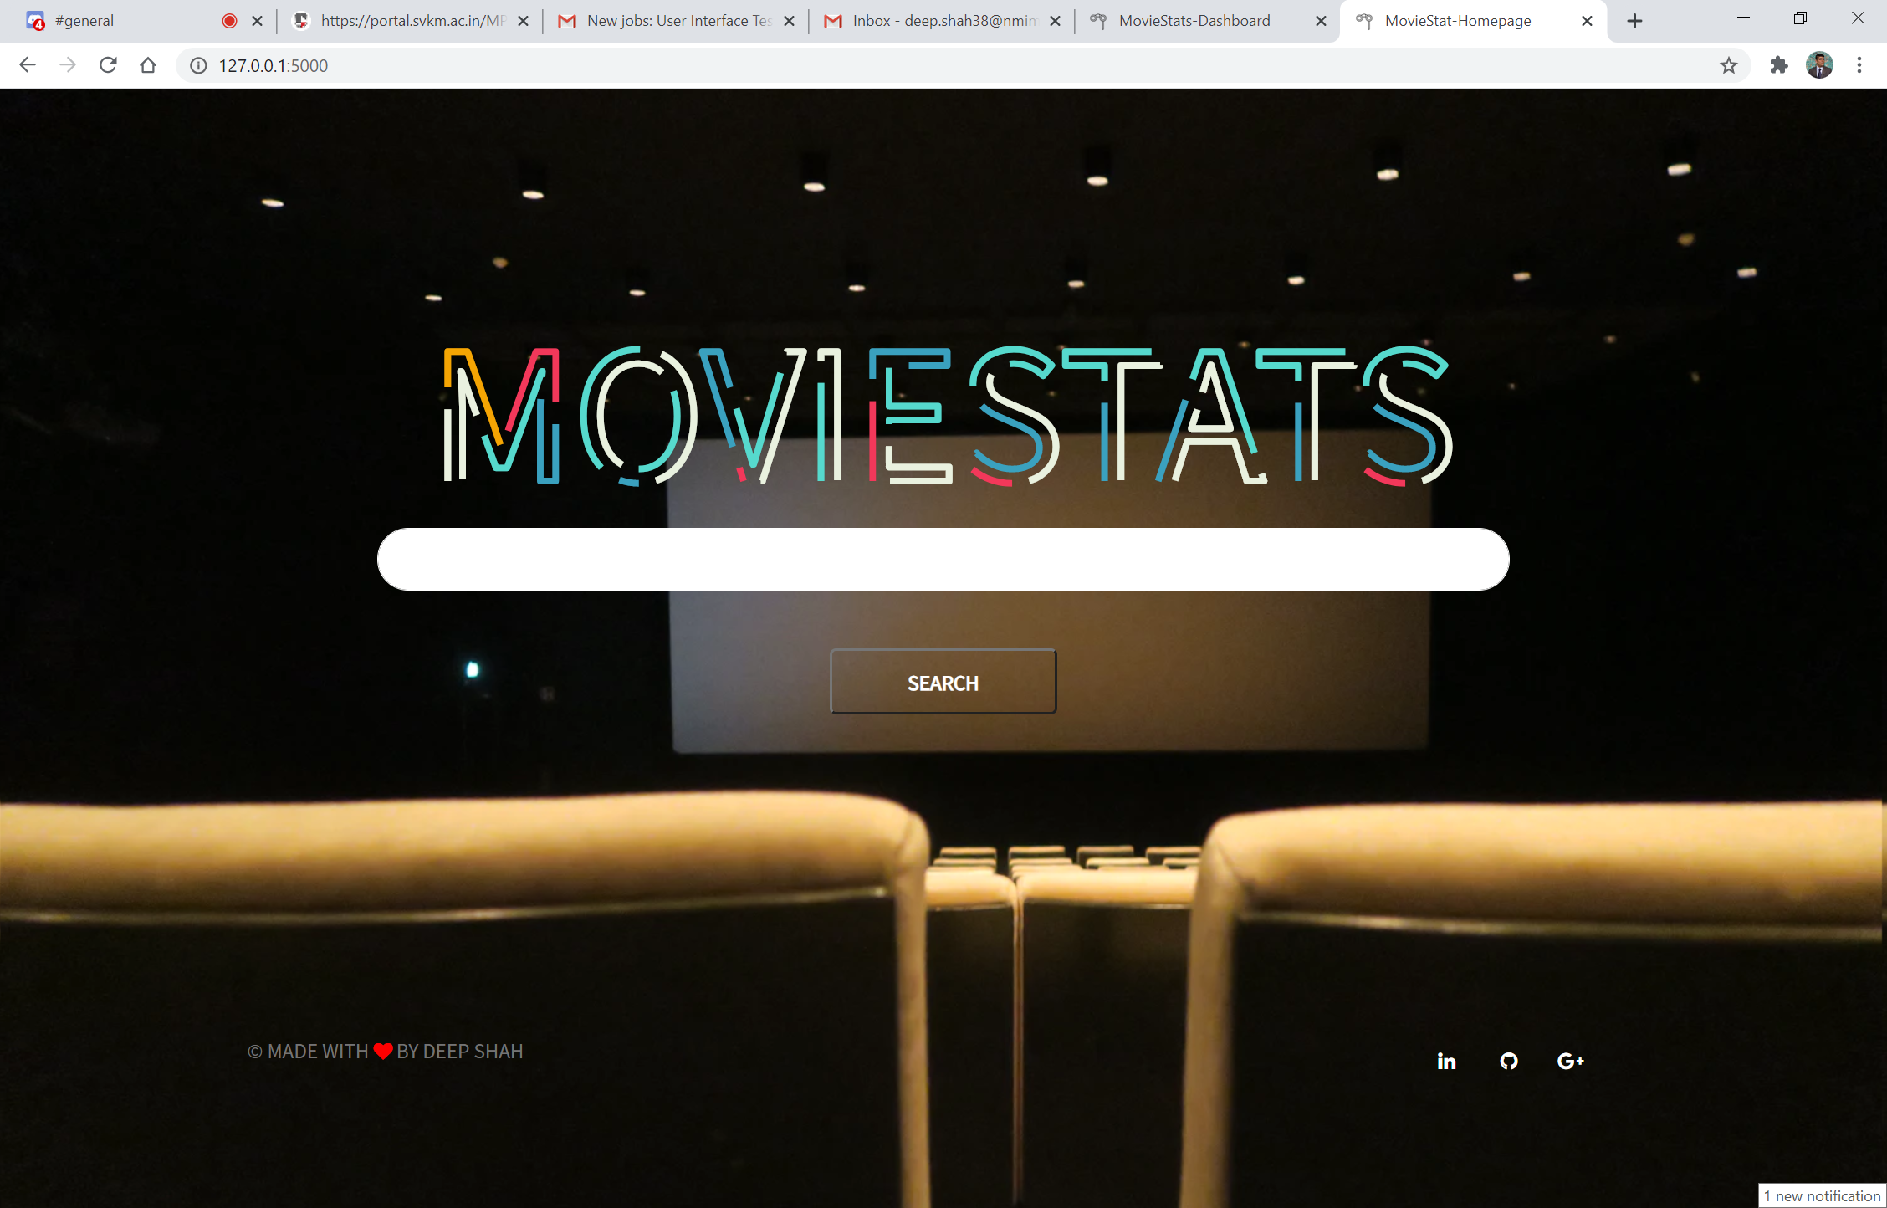

* **dashboard.html**

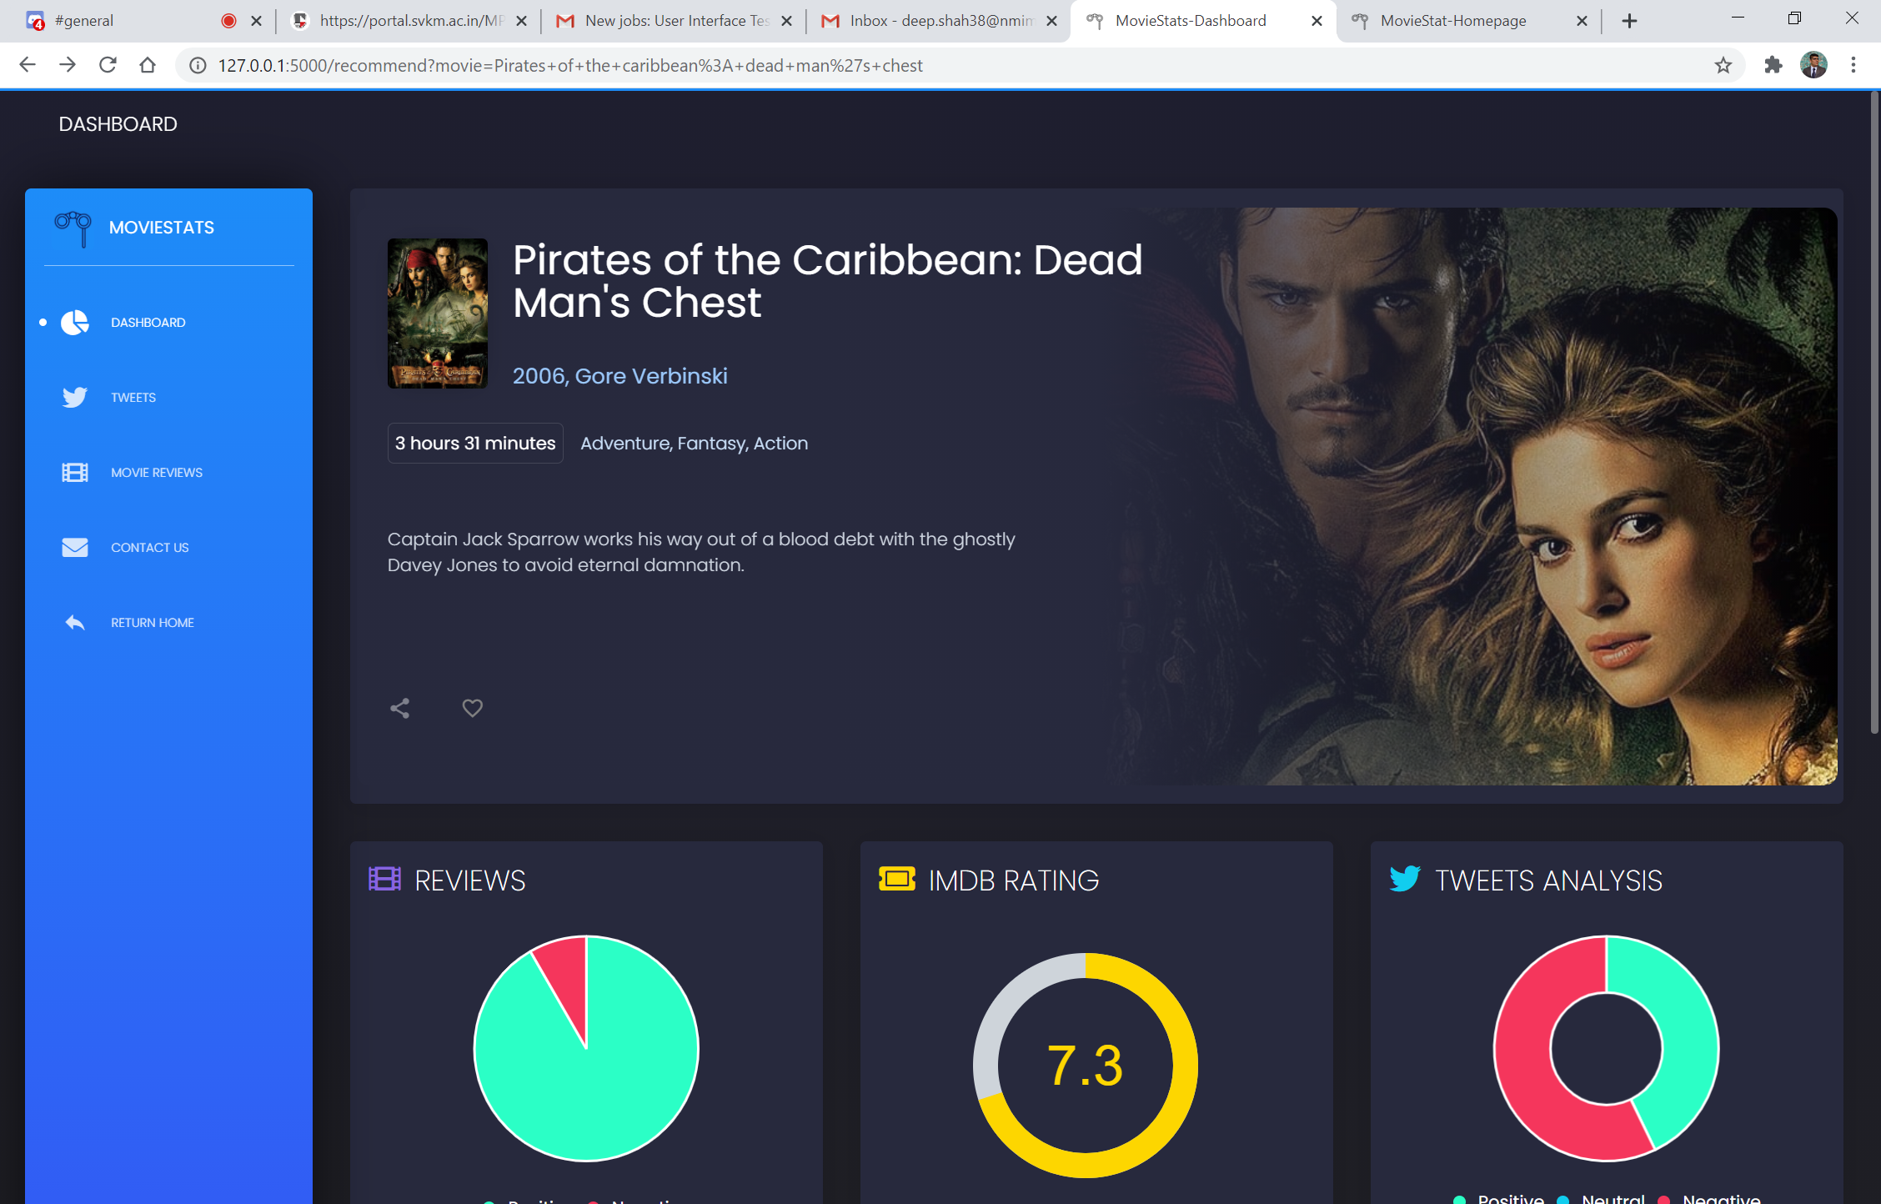

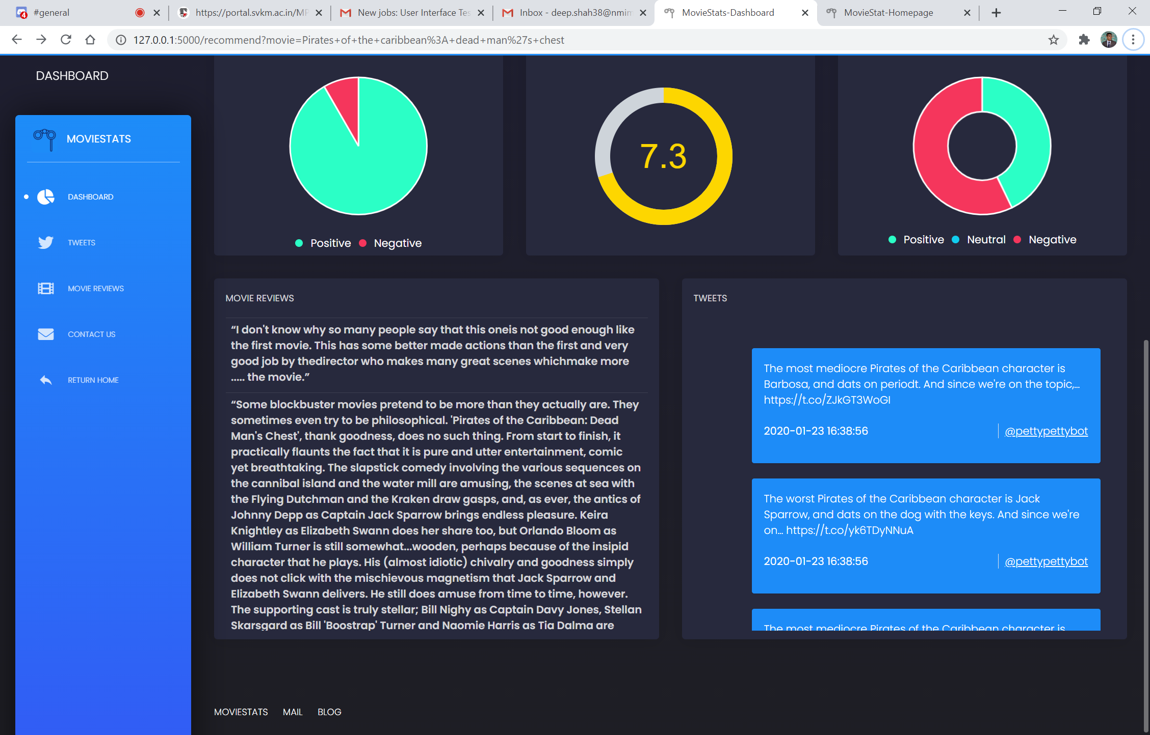

* **tweets.html**

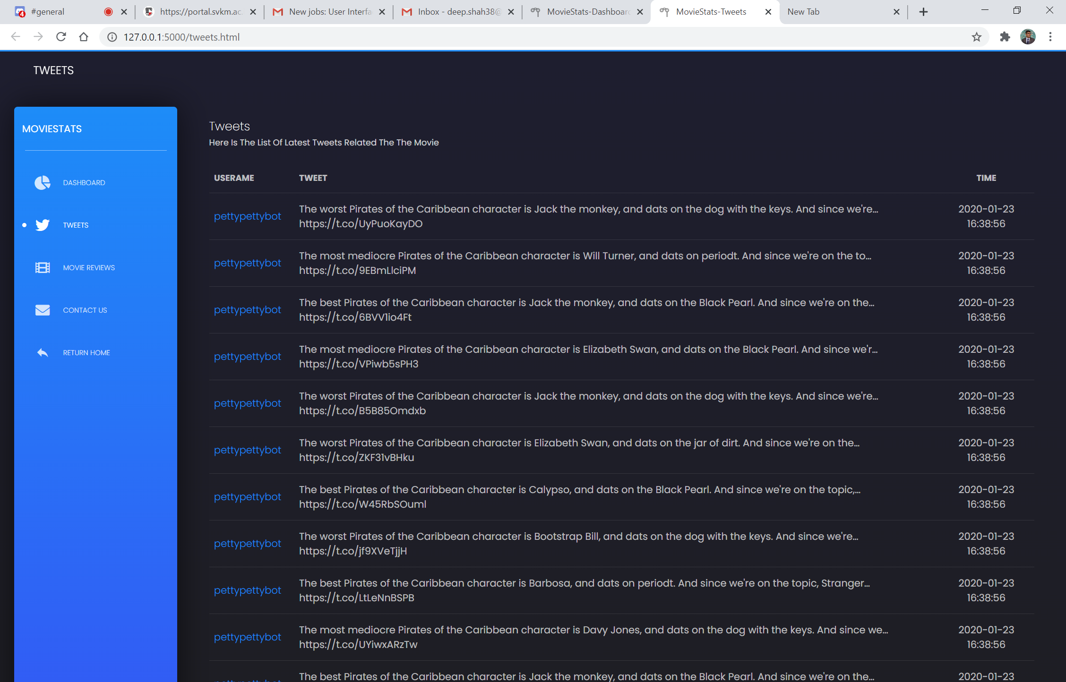

* **moviereviews.html**

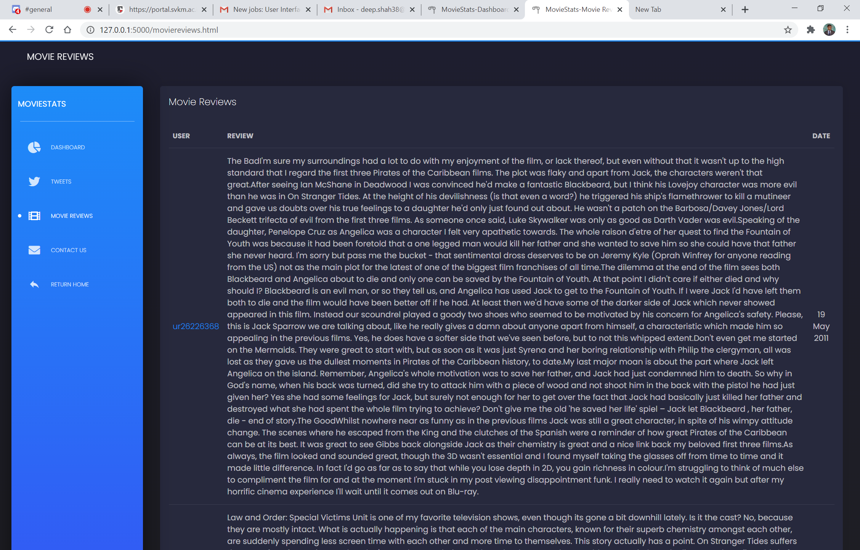

* **contactus.html**

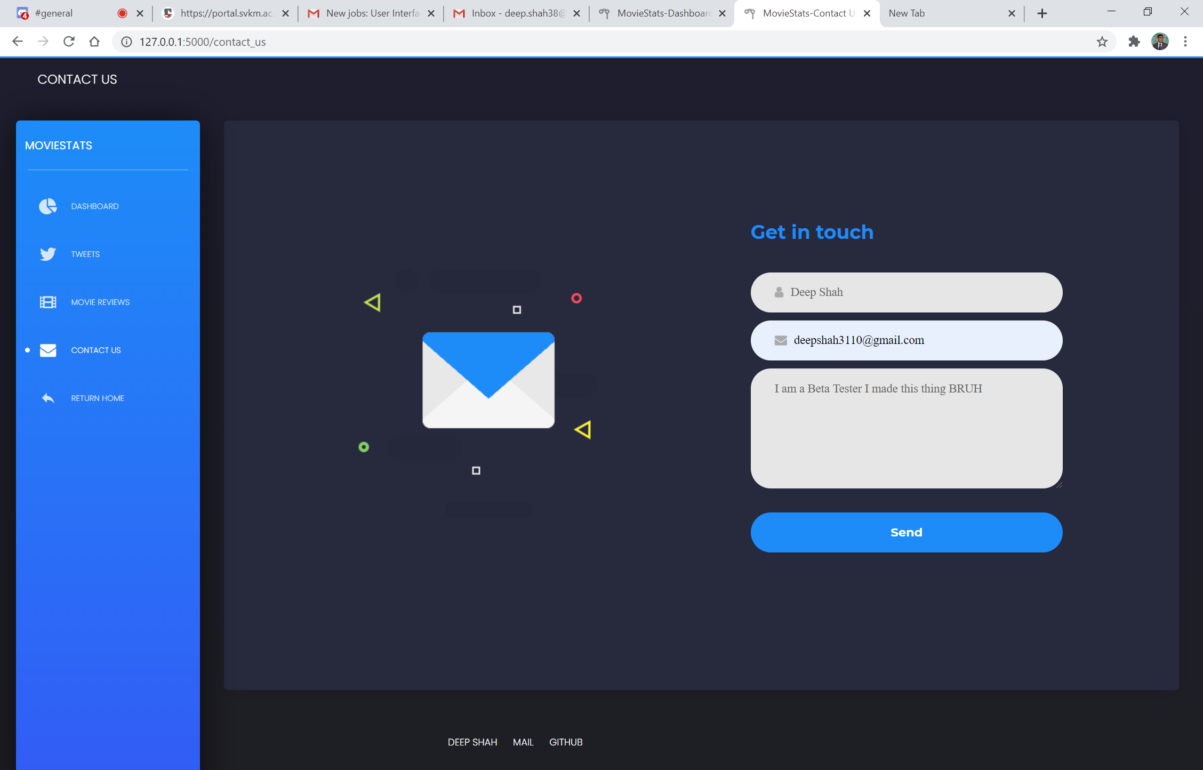

* **thankyou.html**



* **404.html**

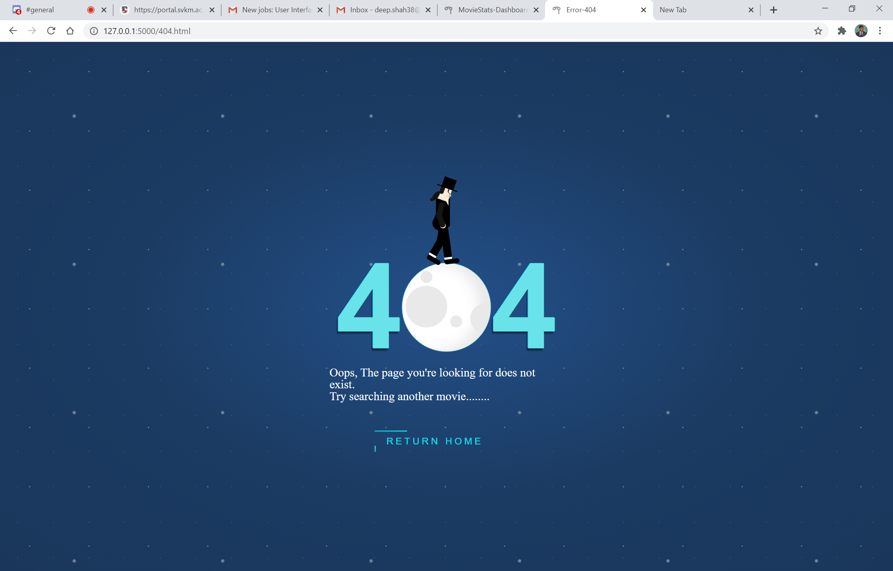

**Datasets:**

* **main_data.csv**

Get suggestions of movie names on Home Page

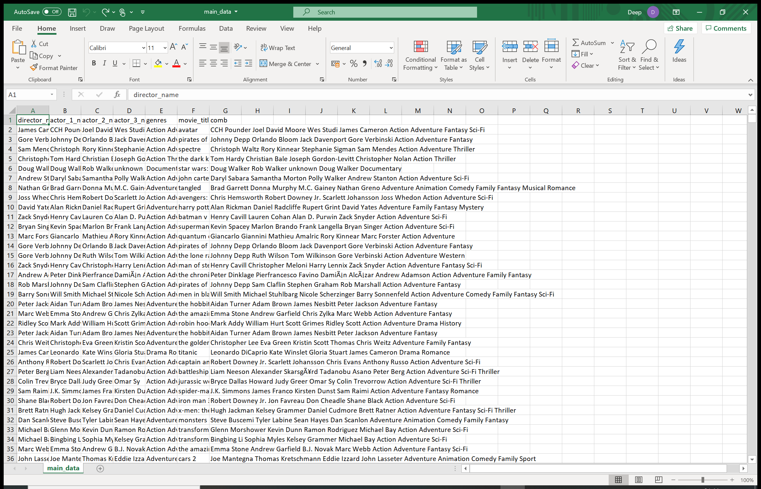

* **database.csv**

It is to save peoples response for contact us form

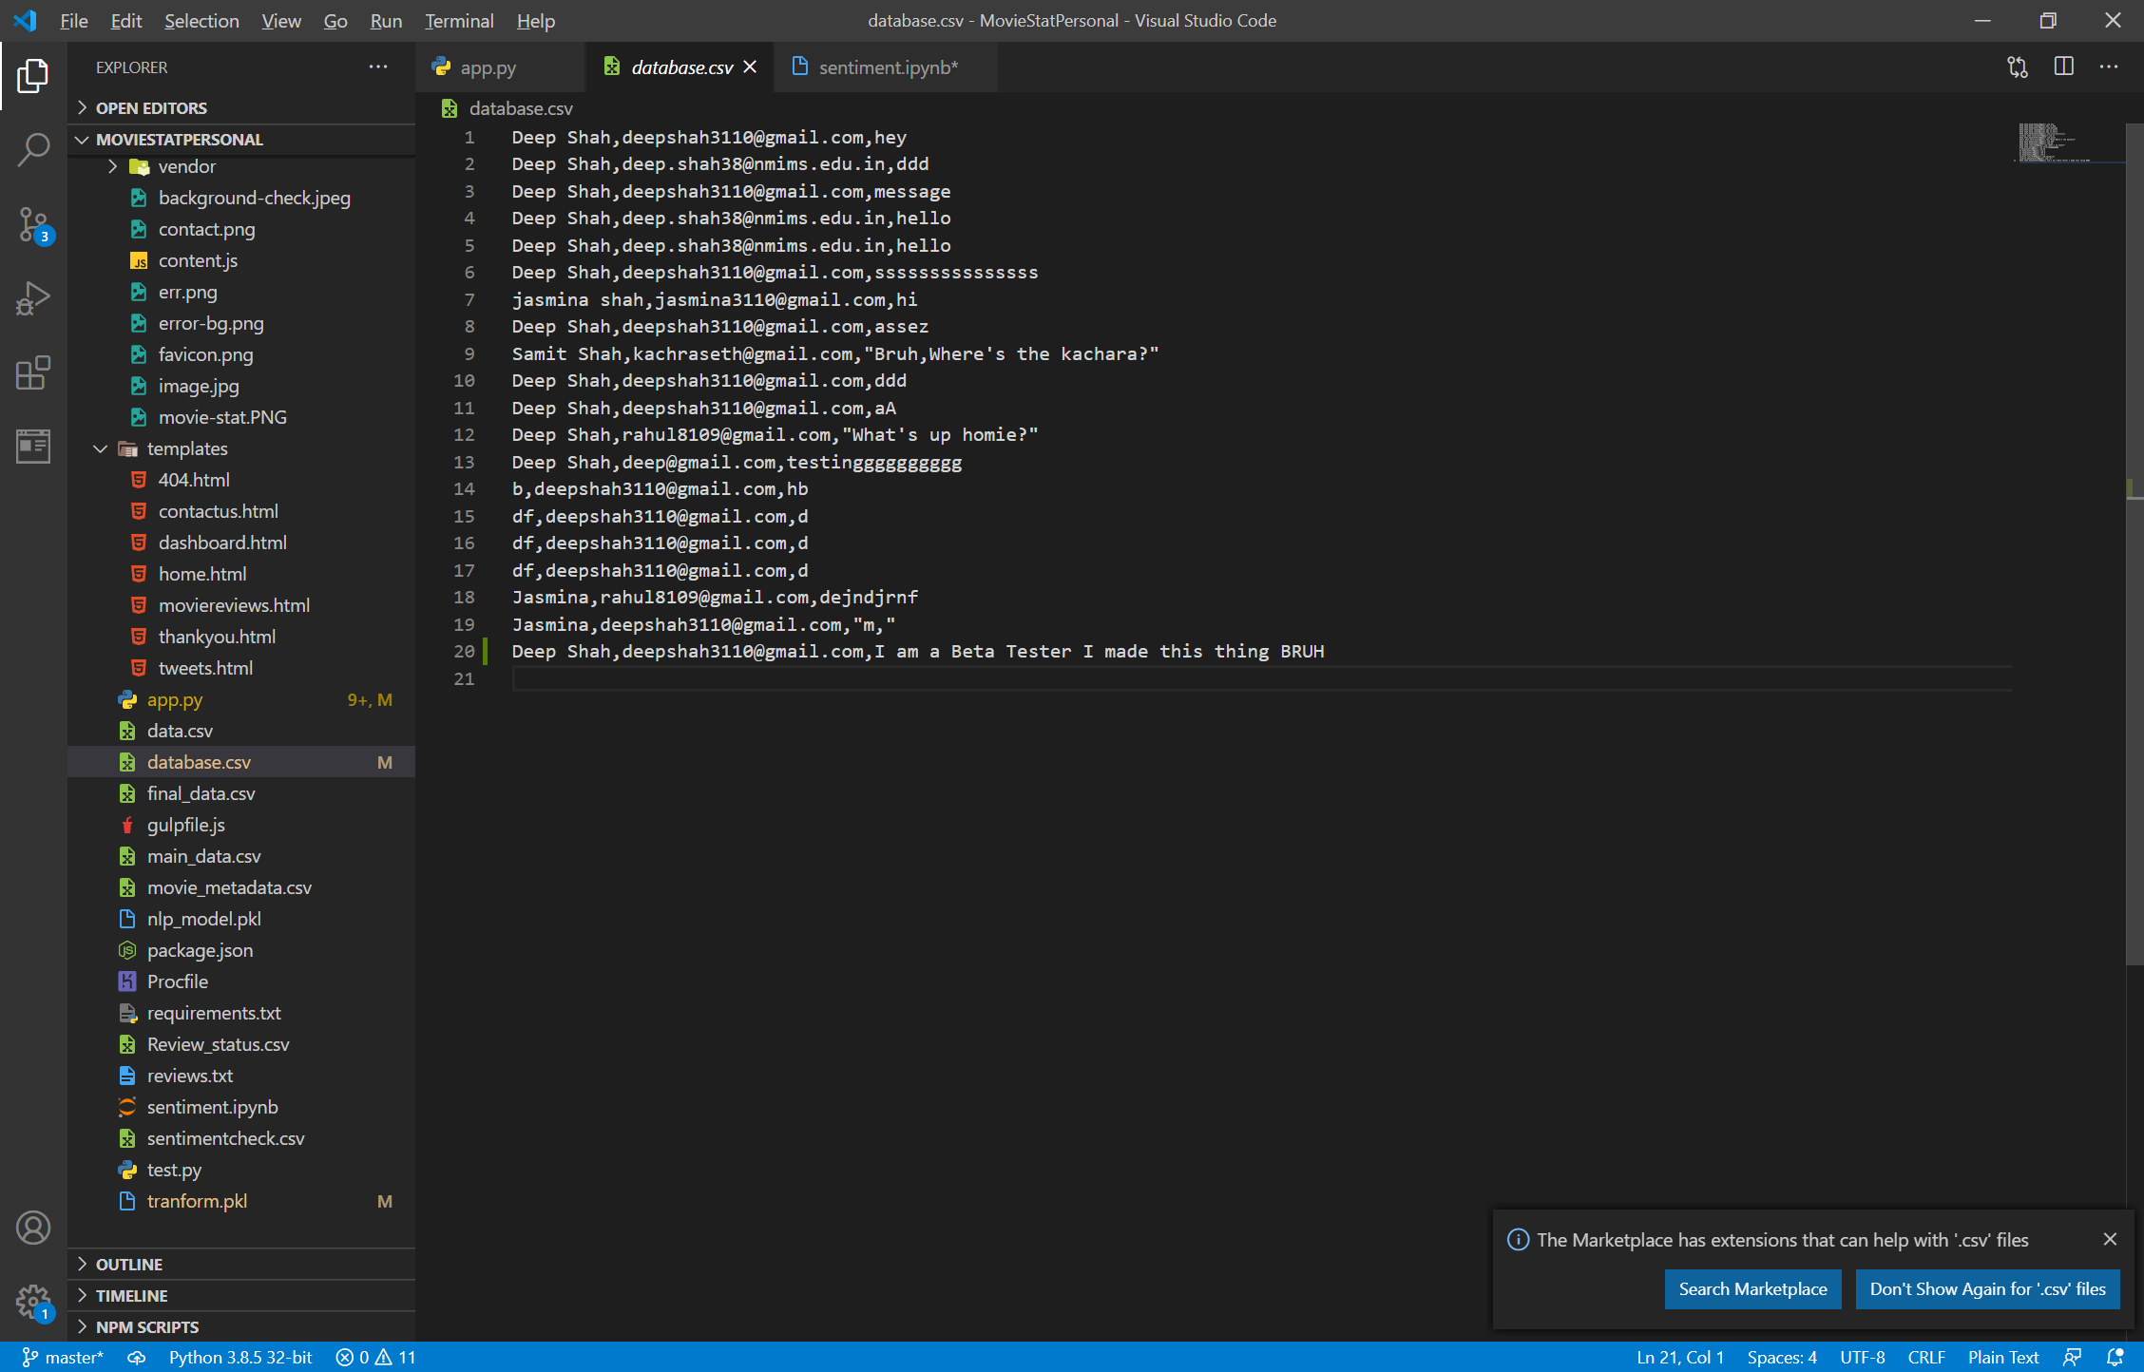

* **data.csv**

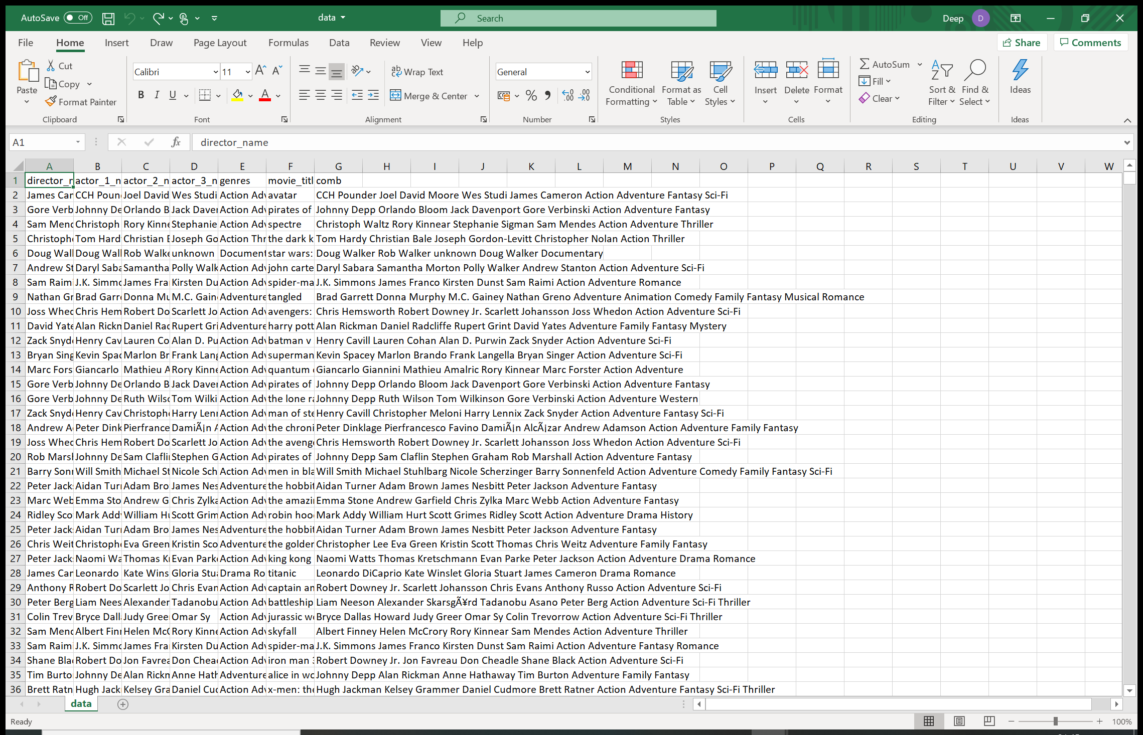

* **final_data.csv**

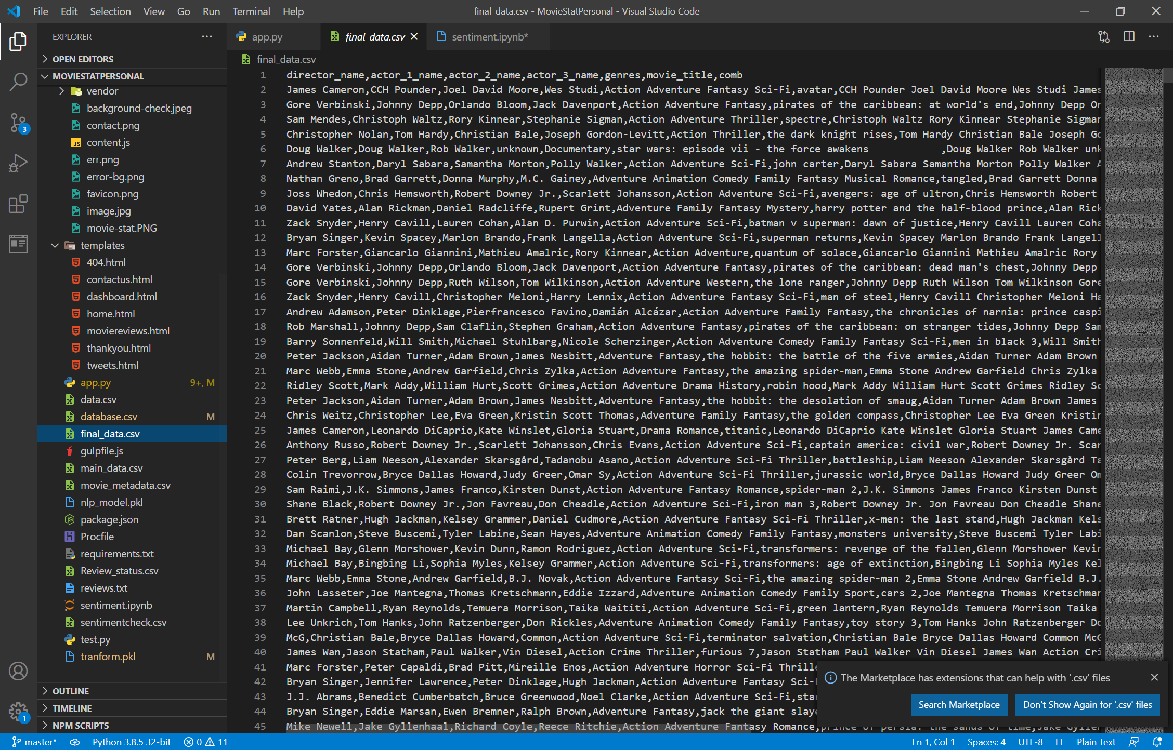

* **movie_metadata.csv**

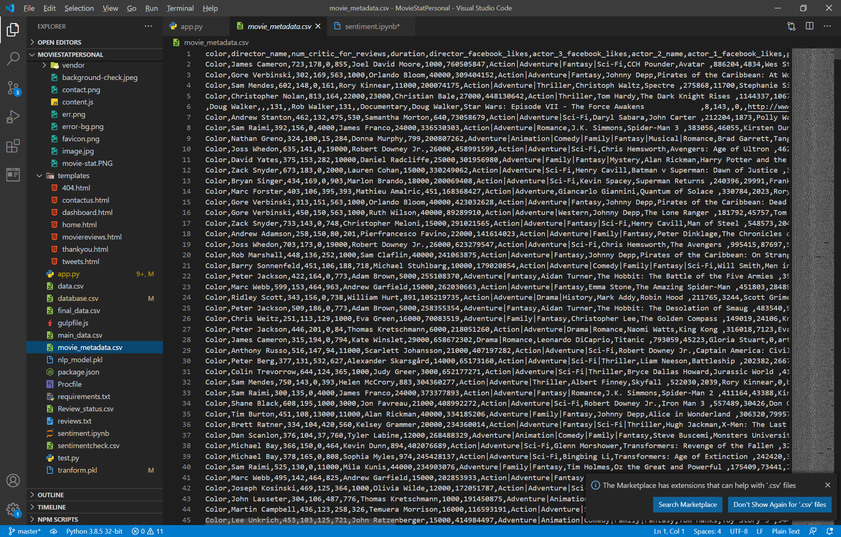

* **Review_status.csv**

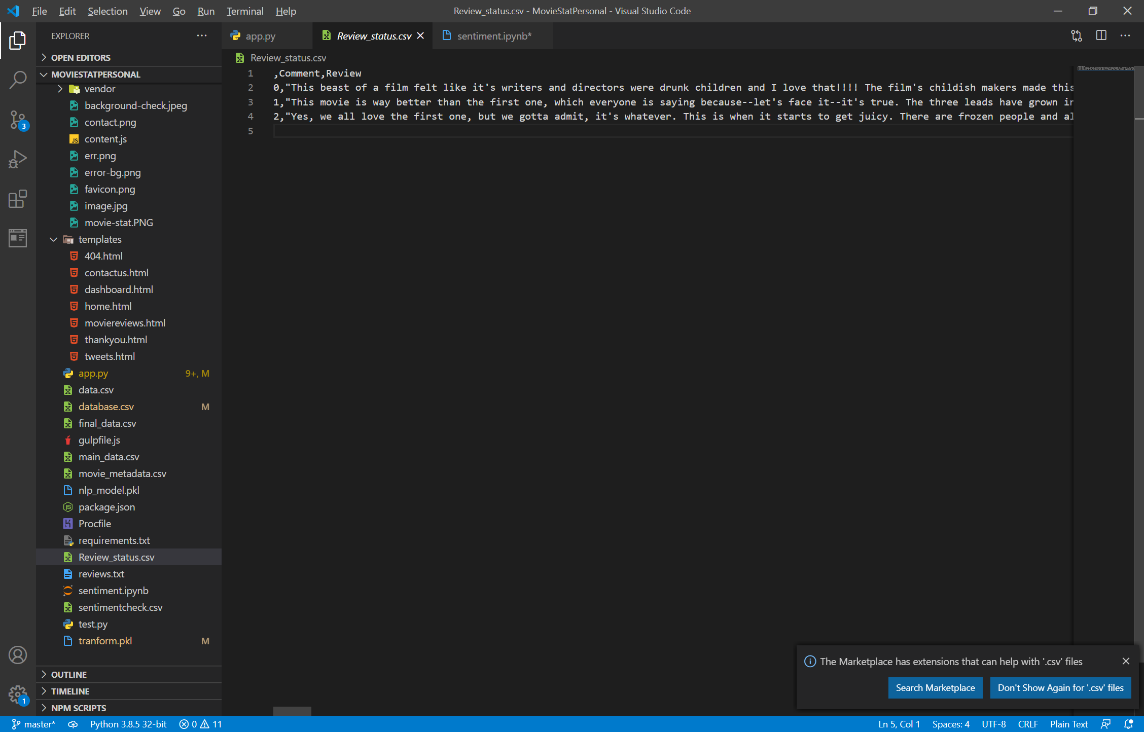

* **Sentimentcheck.csv**

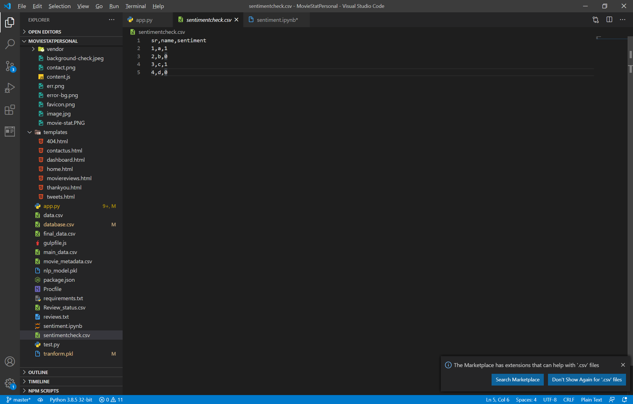

**Python (app.py)**

-It is our main file

-Flask is used to create a server

@app.route(“/”)->home.html

@app.route(“/recommend”)->dashboard.html

@app.route(“/contact_us”)->contactus.html

@app.route(“/thankyou”)->thankyou.html

@app.route(“/tweets.html”)->tweets.html

@app.route(“/moviereviews.html”)->movierevies.html

Note: Download Requirements.txt for Python Packages

**Sentiment.ipynb:** Accuracy 98.77% ;for analysis of moviereviews

**Tweets** are analyzed using python TextBlob Package which gives around 70 percent accuracy

|  |  |
| --- | --- |
| **Tweets Sentiment Analysis** | **Movie Reviews Analysis** |
| Sentiments analyzed using TextBlob Library | Sentiments analyzed using sentiments.ipynb |
| Accuracy:70-80% | Accuracy:98.77% |